34.60: 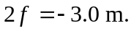
So the smaller mirror must be convex (negative focal length) and have a radius of curvature equal to 3.0 m.

